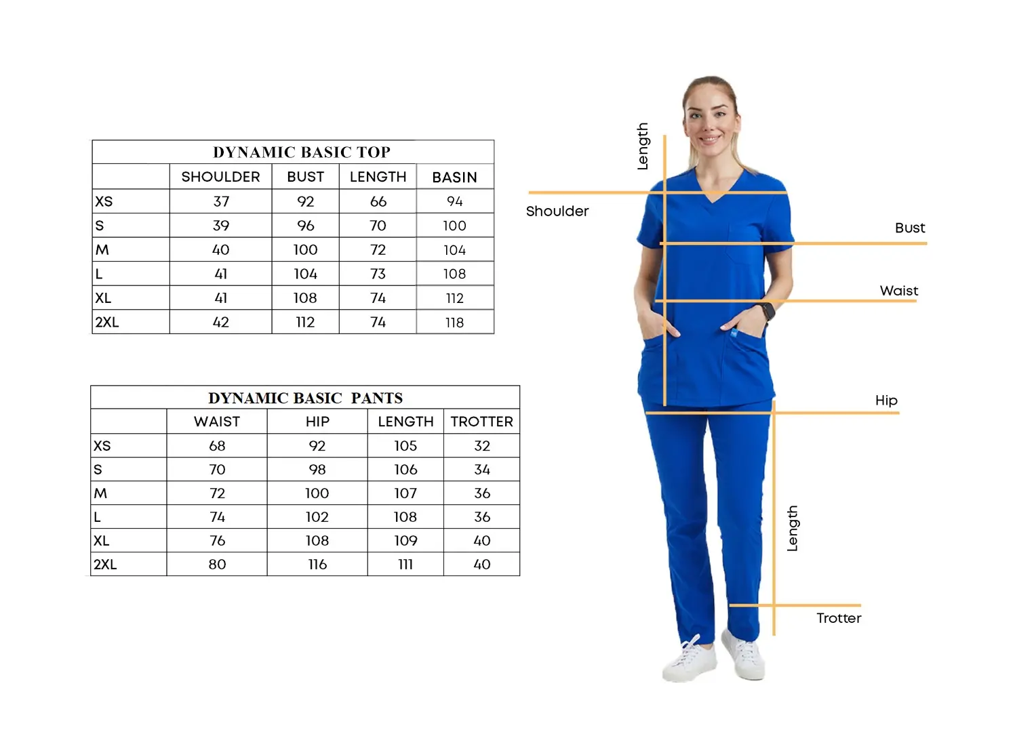 **DYNAMIC COLLECTION**

Size Chart

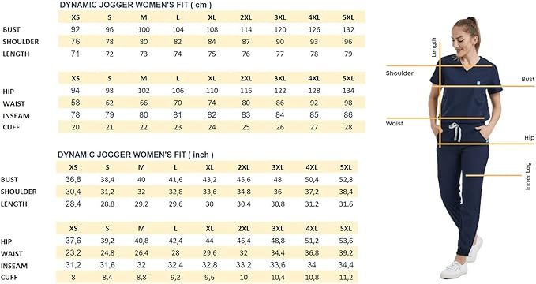

Care Instructions

MACHINE WASHABLE

Wash before use, Wash dark colours separately

Do not Bleach, use colour safe detergents

Wash inside out with similar colours

Machine Wash 40⁰ C

Tumble Dry Low heat

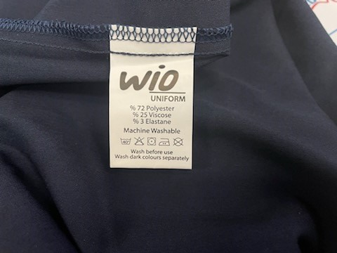Medium Iron

Do not Dry Clean